PONTIFICIA UNIVERSIDAD CATÓLICA DEL ECUADOR
FACULTAD DE CIENCIAS EXACTAS Y NATURALES
ESCUELA DE CIENCIAS BIOLÓGICAS

Regeneration, reproduction and laboratory maintenance of aquatic and land planarians from Ecuador

Disertación previa a la obtención del título de Licenciado en Ciencias Biológicas

EMILIO OVIEDO R.

Quito, 2019

A mi Madre Elizabeth Rivadeneira, por enseñarme que ningún sueño es imposible.

Regeneration, reproduction and laboratory maintenance of aquatic and land planarians from Ecuador

Emilio Oviedo Rivadeneira,¹ Andrés Romero-Carvajal^{1,2}
¹Escuela de Ciencias Biológicas, Pontificia Universidad Católica del Ecuador, Quito, Ecuador
*²Corresponding author. E-mail: maromero@puce.edu.ec

KEYWORDS
Regeneration; cell proliferation; diversity; Parakontikia ventrolineata; Girardia; Geoplaninae; planaria

ABSTRACT

Understanding the cellular processes that explain tissue regeneration strategies in aquatic and land planarians is of great importance to understand how this process has changed from a primitive aquatic environment to a terrestrial one. Although great advances in planarian’s biology have been made at an organismal, cellular and molecular level, many species remain understudied or undescribed. Here, we report some regeneration aspects of a new freshwater planarian species from Ecuador. For this, we have collected, maintained and identified animals to study regeneration through surgical and molecular methods. This sexual species from the Genus Girardia has strong regenerative capabilities, similar to those reported for Schmidtea mediterranea. A spatial and temporal analysis of mitosis in regenerating fragments in Girardia sp. allowed us to observe a biphasic pattern by 6 h and 48 h in posterior fragments. Differently, anterior fragments presented only the first peak (6 h). To better understand this process in other the poorly studied land planarians, we have identified Geoplaninae sp., which also has strong regenerative capabilities. This land species is able to regenerate in almost one month (24 days). We concluded that Girardia sp. is an ideal model to study regeneration at a cellular and molecular level, which enable us to start comparative analyses with freshwater and land planarians (e.g., Geoplaninae sp.) species that present different regeneration responses.

INTRODUCTION

Planarians (Tricladida, Platyhelminthes) have fascinated scientists for their extraordinary capacity to regenerate whole animals from small severed fragments (Elliott & Sánchez Alvarado, 2013a). The extraordinary capacity of planarians to regenerate all the missing organs after amputation is given by the presence of adult stem cells (ASCs) called neoblasts (Baguna, Salo, & Auladell, 1989), which play an essential role in tissue homeostasis and repair by participating in cell proliferation, cell differentiation and cell death (Sánchez Alvarado, Tu, & Pearson, 2012). These heterogenic populations of cells are the only mitotic cells in planarians and are distributed along the mesenchymal tissue across the whole body, except before the photoreceptors and within the pharynx (Baguñà, 2012; Fincher, Wurtzel, de Hoog, Kravarik, & Reddien, 2018; Reddien & Alvarado, 2004). When a planaria is amputated, a proliferation signal is triggered and muscle constriction reduces the wound size (Pedersen, 1976; Rink, 2013). Then, the ASCs respond with events of proliferation and migration to the wound site, forming a mass of undifferentiated cells called blastema, which will differentiate later into the missing body tissues and structures (Morgan, 1898; Oderberg, Li, Scimone, Gaviño, & Reddien, 2017; Randolph, 1897; Wenemoser & Reddien, 2010). In Schmidtea mediterranea, two cell proliferation events take place at different time points, one systemic and another at the wound site (Wenemoser & Reddien, 2010). Quantifying and analyzing this phenomenon is key to compare regenerative responses in different species (Pellettieri et al., 2010). Most of the molecular and cellular regeneration studies in planarians have been done in a few limnic species (Schmidtea mediterranea and Dugesia japonica); yet, it’s not known if the same processes apply to marine and terrestrial species (Elliott & Sánchez Alvarado, 2013b). Since land planarians (Terricola) have one evolutionary origin on ancestral aquatic planarians (Dugesiidae) (Álvarez-Presas, Baguñà, & Riutort, 2008; Riutort, Álvarez-Presas, Lázaro, Solà, & Paps, 2012), to study the first ones will provide us a better understanding on how the regeneration process has evolved in response to environmental changes such as terrestrial colonization.
In this study we standardized protocols for laboratory maintenance, surgical procedures and immunohistochemistry with the aim of study regeneration at a morphological and cellular level, and reproduction in freshwater planarians (Girardia sp.). In addition, we were able to study regeneration morphologically in the land planarian Geoplaninae sp., which opens the possibility of studying the evolution of the cellular and molecular regeneration mechanisms between land and freshwater planarians.

RESULTS

- Diversity and reproduction
- Identification
In order to study the regeneration responses in planarians, we collected specimens from land and freshwater environments. Freshwater planarians were collected in the Pita River, and land planarians were collected in Armenia’s Park, both in the south-eastern valley of Quito, Ecuador. Before starting experiments on regeneration, laboratory maintenance and identification studies were performed. To identify the specimens, we extracted DNA for phylogenetic analyses. The phylogenetic tree generated using fragment sequences from the Cytochrome Oxidase I (COI) and Elongation Factor 1-alpha (ef1α) amplified allowed us to identify the Genus of the freshwater holotypes DB_00011 and DB_00051 (figure 1), the subfamily of the land holotype DB_00061 (figure 2) and the species of the land holotype DB_00031 (figure 1 and 2) collected in Pontificia Universidad Católica del Ecuador. DB_00011 and DB_00051 (freshwater holotypes, figure 1) are grouped among species of the Genus Girardia, a sister clade of the Genus Schmidtea, within the Dugesiidae family, with some support from posterior probability (PP) of 0.66. These holotypes, hereafter referred to as Girardia sp., appear to correspond to new species of freshwater planarians from the Andean valleys of Ecuador (manuscript in preparation). In reference to the land planaria, DB_00061 (Armenia’s holotype), phylogenetic analyses showed that this sample belongs to the Geoplaninae subfamily with high support from the posterior probability values (PP=1). These holotypes are hereafter referred to as Geoplaninae sp. Finally, the holotype DB_00031 (PUCE holotype) resulted within Parakontikia ventrolineata clade with a strong support (PP=1). This is particularly interesting, since this suggests the presence of an Australian invasive species in Ecuador. Still, histological studies are needed for confirmation. Histological analyses for both freshwater and land planarians are being performed by Fernando Carbayo, PhD. at the University of São Paulo (USP), Brazil.

- Reproduction on Girardia sp.
Freshwater planarians (F0) were collected beneath rocks in the Pita River and brought into the laboratory to be cultured. When cocoons were deposited, each one was separated from the parental’s terraria and was observed until hatching. 15 cocoons were obtained in laboratory conditions between August and November of year 1, with an average of 3 viable embryos (F1) born per cocoon. Cocoons are capsules that contain fertilized eggs and yolk cells that are the source of food for the embryos (figure 3B) (Sluys & Riutort, 2018). From each cocoon, one to eight embryos hatched. Girardia sp. embryo’s development in year 1 lasted on average 43 days from cocoon deposition to hatching. Fertility season was measured from the time of first to the last fertile cocoon deposition. After this period, we got a total of 24 embryos, 5 of which survived to adults. The last three cocoons in the colony were unfertile (no embryos hatched), so they were not taken into account (Table 1). From the 5 surviving adults (F1), 9 cocoons were collected between July and October of year 2, with an average of 2±1 embryos (F2) born per cocoon. Development lasted on average 33 days from cocoon deposition to hatching, and a total of 10 embryos were obtained, but only 4 survived. The second cocoon deposited was unfertile. In all cases, hatchlings emerged without pigmentation (figure 3A), similar to what was reported in Schmidtea mediterranea (Sluys & Riutort 2018). In conclusion, Giardia sp. reaches adulthood within one year after fertilization, lays, on average, 12 cocoons per year and embryo’s development on average last one month and a week.

- Regeneration in Girardia sp. and cell proliferation
- Regeneration stages
As a starting point to analyze regeneration in Girardia sp. and to compare it with other species, we studied this process morphologically. Regeneration in Girardia sp. was analyzed according to the regeneration stages (st) proposed for Girardia tigrina, which are defined as follows: wound healing, st 1; blastema formation, st 2; grow and early differentiation, st 3, and definitive differentiation, st 4 (Spiegelman & Dudley, 1973). Regeneration was tracked visually (no histology was made) from the intact state to 35 Days post-amputation (Dpa). Two transversal cuts were made: middle cut and head amputation. Regeneration caused by the transverse middle and the head amputation cuts lasted on average 13 days on posterior fragments. We cannot assure regeneration lasted the same period of time on anterior fragments because most of the planarian’s organs are difficult to observe without histology. Hence, regeneration time was measured by analyzing posterior fragments. Animals reached stage one on the first day (no picture shown); st 2, on the third day; st 3, on 6th to 9th days, and definitive differentiation started on the 13th day (figure 4 and 5). After amputation, a muscle constriction reducing the wound size was observed (st1). Three days later, a mass of cells without pigmentation formed at the wound site (st2) (figure 4A, G. figure 5A, G). This mass of cells continued to grow until day 9 (st3) (figure 4B, C, H, I. figure5B, C, H, I). Finally, two eyespots were visible at day 13, indicating the end of the regeneration process (figure 4D, J. figure 5D, J). From there, animals continued with tissue pigmentation and remodeling (figure 4E, F, K, L. figure 5E, F, K, L).

- Cell proliferation analyses
To measure the regenerative response of Girardia sp. to injury and compare it with other species, we analyzed cell proliferation after a cut made posterior to the pharynx. The analysis of cells immunolabeled with an antibody against the phosphorylated portion of the histone 3 (H3P) was done at key time points in posterior and anterior fragments (figure 6A-K). This cells were visualized in a fluorescent microscope that captured the red fluorescent signal of the secondary antibody. We found a temporally biphasic mitotic pattern in the posterior fragment, with a first mitotic peak within 6 hours (h), that occurred throughout the whole animal (figure 6C, H, L). This systemic peak doubled 3 h cell numbers. After the first mitotic peak, a decrease in mitotic numbers occurred by 18 h (figure 6L). By 48 h, a second mitotic peak occurred near the wound site (figure 6L, N). This second mitotic peak tripled 18 h cell numbers. Finally, mitotic numbers decreased by 192 h to baseline in the posterior fragments. Anterior fragments had only the first mitotic peak by 6 h, and, from there, proliferation decreases to the baseline (figure 6L). The 48 h increase in cell proliferation is caused by mitotic cells located right after the wound (within the first quarter). This cellular behavior was seen in both anterior and posterior fragments, but was not detected in other time points, where most of the proliferating cells were located towards the middle of the fragment (between the 2nd and 3rd quarters of the fragment) and decreased to the ends (figure 6E, J, N, M).

- Regeneration in the land planarian Geoplaninae sp.
- Regeneration stages
In order to understand the differences between regeneration responses of planarians of land and freshwater environments, we analyzed morphologically the response to injury of Geoplaninae sp., with the aim to start regeneration analyses at a deeper level. In Geoplaninae sp. specimens a transverse middle cut was done and was tracked through 33 days (figure 7). Regeneration was analyzed equally to Girardia sp. Animals reached stage one on the first day; st2, on the fourth day; st3, on the 13th day and definitive differentiation started on the 24th day. After amputation, muscle constriction reducing the wound size was observed (st1) (figure 7B, G, L, Q). Four days later, a mass of cells without pigmentation formed at the wound site (st2) (figure 7C, H, M, R). This mass of cells continued to grow until day 13 (st3) (figure 7D, I, N, S). Finally, by day 24, pigmented cells started to migrate to the blastema (figure 7E, J, O, T). From there, animals continued with tissue pigmentation and remodeling (figure 7F, K, P, U).

DISCUSSION

- Diversity and reproduction
- Diversity
The holotypes DB_00011 and DB_00051 resulted among species of the genus Girardia. This topology observation, the fact that in Ecuador only one biodiversity study in planarians was done describing Girardia festae from some locations in Ecuador (Tulcán, Cañar, Cuenca, Culebrillas Lake and Yahuarcocha Lake) in 1898 (Borelli, 1898), and the limited dispersion capacity of freshwater planarians due to their limited resistance to desiccation and absence of larvae with dispersive capacity (Lázaro & Riutort, 2013), allowed us to conclude that the holotypes DB_00011 and DB_00051 are a new Girardia species, native to Ecuador (Description in preparation) (figure 1).
The holotype DB_00061 resulted within the Geoplaninae subfamily. All the clade presents a strong support (PP=1), but our holotype does not present a node. Therefore, further studies at a molecular and morphological level are needed to identify this species.
The holotype DB_00031 resulted within Parakontikia ventrolineata clade with strong support (PP=1). This observation and histology analysis (data in preparation) allowed us to identify this holotype as Parakontikia ventrolineata. This land flatworm is a native species from Australia, but was found in Europe, South Africa, and North America as an invasive species. This species described in 1892 by Arthur Dendy could possibly affect native soil ecology and diversity similar to what Platydemus manokwari and other Austral-Asiatic aggressive colonization species have done in Europe and the United States, equally by eating local earthworms, slugs, and snails (Sluys, 2016; Jones, Johns, & Winsor, 1998; Justine et al., 2015; Justine et al., 2018; Mazza et al., 2016).
In conclusion, for the first time in many years, we report new Ecuadorian planarian species, including the finding of an Australian invasive that could be affecting local ecology and diversity. Further studies are needed in order to elucidate the taxonomy of this group in Ecuador.

- Reproduction
Here, we report another stream-dwelling species that lays cocoons (Girardia sp.), being the third reported species of the genus that produces spherical and stalked cocoons with an endplate (figure 4B), similar to other species of Schmidtea and Cura (Sluys & Riutort, 2018). When cocoons are deposited, these are yellowish, but darken to become brown as reported in other freshwater planarian species (Sluys & Riutort, 2018). From each Girardia sp. cocoon, one to eight embryos hatched. Therefore, as previously reported for Schmidtea polychroa, Girardia sp. embryos while developing must compete for yolk cells until hatching (Cardona, Hartenstein, & Romero, 2006).
The majority of ecological research has been done in British species (Vila-Farré & C. Rink, 2018). Lake-dwelling species lay cocoons between early spring and early summer, while the stream-dwelling species usually reproduce asexually with some exceptions (Ball and Reynoldson, 1981). Crenobia alpina and Phagocata vitta, for example, lay cocoons during the winter (Ball and Reynoldson, 1981).
Some authors had related the asexual reproduction of planarians to their regenerative power, but many tricladids with sexual reproduction regenerate very well as we have shown with Girardia sp. which regenerates in 13 days and lays cocoons every year (Sluys & Riutort, 2018).
Given that only European species have been studied, little ecological data is known from tropical areas, therefore more studies are needed in order to enhance the understanding of the ecology of this group (Vila-Farré & C. Rink, 2018).

- Regeneration in Girardia sp. and cell proliferation
  - Regeneration stages
After amputation, Girardia sp. took around 13 days to regenerate all the missing organs. We were able to observe the two processes that occur during regeneration: morphallaxis and epimorphosis. Morphallaxis is the remodeling of pre-existing tissue. This process was more evident in Girardia sp., just after regeneration ended (day 13). On the other hand, epimorphosis is the generation of new tissue by proliferation. This process was evident from blastema’s formation to differentiation start (Morgan, 1898). However, these processes seem to explain regeneration partially due to the lack of information at a cellular or molecular level. Therefore, the intercalation theory seems to explain better the regeneration process. This theory, based on molecular experiments, explains that regeneration is controlled by positional information. First, a distal portion is formed around the wound site. Then, this distal portion interacts with the remaining proximal portion, inducing a reorganization of positional information. Finally, lost tissues are intercalatively generated (Agata, Saito, & Nakajima, 2007). This theory was not evident in our experiments, since only morphological analyses were done. On the other hand, our results show no significant differences between the cuts made, suggesting that fragments of all sizes regenerate by the same time. In contrast, it has been shown that some planarians species present “Regenerative Gradients”, in which regeneration rate declines from anterior to posterior. This difference in the rate of regeneration could be related to the anterior/posterior polarity of planarians tissue (Child, 1941). Some researchers have reported it in Phagocata gracilis (Buchanan, 1933), Dugesia dorotocephala (Child, 1911) and D. lugubris (Dubois, 1949) (Reddien & Sanchez Alvarado, 2004).
In the animal world, the capacity for regeneration is very variable. Indeed, animals of the same genus differ on it. For example, the nemerteans Lineus ruber and Lineus viridis live in the same environment and are morphologically identical, but L. viridis cannot regenerate (Brockes, Kumar, & Velloso, 2001). Similarly, in some planarian species such as Dendrocoelum lacteum (Morgan, 1904) and Bdellocephela punctata (Brondsted, 1939) regeneration of a tail is possible in both anterior and posterior regions, but only anterior regions can regenerate a head. Therefore, the regeneration capacity of other planarian species needs to be studied, principally in tropical areas where no studies have been done. Here, we report that Girardia sp. can regenerate as well as Girardia tigrina, but the last one takes half of the time to complete the process (Spiegelman & Dudley, 1973). It is important to mention, that our experiments were done at room temperature (22°C in average) while the experiments made on G. tigrina were done at 17 °C. Although Girardia sp. specimens regenerated in a warmer environment, they took longer in regenerate. Hence, temperature does not explain this result. Further studies with molecular, environmental and phylogenetic analyses are needed to elucidate these differences.

  - Cell proliferation analyses
Two early proliferation peaks occurred in Girardia sp., as previously reported in Schmidtea mediterranea and Dugesia tigrina (Saló & Baguñà, 1984; Wenemoser & Reddien, 2010). Conversely to the previously reported in S. mediterranea (Wenemoser & Reddien, 2010), our results showed a most pronounced response from the posterior fragments. Indeed, anterior fragments only presented the first mitotic peak. We explain this based on the apoptosis study of Pellettieri et al., (2010), which shows that the magnitude of the second systemic response depends on the type of fragment. If the fragment requires functional integration of new and preexisting organs, the response is more pronounced. Therefore, as the posterior fragments lost more organs (brain, eyespots, gut, pharynx, etc.), they needed a higher response to integrate new and preexisting organs. In conclusion, fragments that lose more organs have more aggressive proliferation and apoptosis responses, which are required for epimorphosis and tissue remodeling. On the other hand, our results showed a larger numbers of cells by 48 h in anterior and posterior fragments at the wound site. Previous studies in S. mediterranea have reported that this phenomenon is due to migration of cells to the wound site, where later some differentiate and some undergo mitoses. They explain that this second peak is a missing-tissue response (Wenemoser & Reddien, 2010). Nevertheless, in the anterior fragment we only observed cell recruitment, but not a second mitotic peak. As cell proliferation is controlled by many factors (feeding, starvation, stress, injury, etc.) (Baguñà, 1976; González-Estévez, Felix, Rodríguez-Esteban, & Aboobaker, 2012; Oviedo, Newmark, & Sánchez Alvarado, 2003), further studies with more samples and controls are needed to elucidate this phenomenon in Girardia sp.

- Regeneration in land planarian Geoplaninae sp.
  - Regeneration stages
Currently, few land planarian regeneration studies are available. This is because of the time in history this research was done. Many naturalists started to do morphological regeneration studies in land planarians, but couldn’t go further due to the limited research tools they had at that time (Elliott & Sánchez Alvarado, 2013a). When molecular and cellular tools were developed, most of the regeneration studies were and are done in freshwater species. Therefore, we begin to study Geoplaninae sp. regeneration at a morphological level as the first step to start molecular research in land planarians. Geoplaninae sp. presents a regenerative process similar to the one in freshwater planarians, but takes longer (24 days). These results resemble to the regeneration studies T. H Morgan (1900) made in the land planarian Bipalium Kewense, which takes almost 3 weeks to regenerate (Morgan, 1900). Currently, it is not known the cell proliferation responses that land planarians (e.g., Geoplaninae sp.) have to deal with injury. Therefore, the next step in our research will be to study, by immunostaining, this responses in Geoplaninae sp. This will allow us to give insight on how this response changes in animals from a land environment.

- Concluding remarks and further experiments
We conclude that sexual Girardia sp. is a new native Ecuadorian species that presents similar regenerative capacities to S. mediterranea; making it an ideal model to study regeneration at a cellular and molecular level. Furthermore, we have demonstrated that Girardia sp., differently to the reported in S. mediterranea, presents a markedly response in mitoses to injury in fragments that lose most of the organs, and that fragments that lose few organs only respond with the first mitotic peak.
In addition, as we have shown Geoplaninae sp. regeneration capabilities, we propose to carry out cellular and molecular experiments in land planarians to enhance our understanding of the regenerative response of tricladids and its evolution.

Methods for the study of Girardia sp. and Geoplaninae sp. regeneration

- Specimen collection
80 Aquatic planarians from the genus Girardia sp. were collected at various time points in the Pita River, Province of “Pichincha”, near “Molinuco” installations. The altitude is 3700 m above sea level. The geographic coordinates of this site are 0°25'12.69'' S 78°24'25.84'' O. 20 land planarians (Parakontikia ventrolineata) were collected at Pontificia Universidad Católica del Ecuador, Province of “Pichincha”. The altitude is 2850 m above sea level. The geographic coordinates of this site are 0°12'36.4" S 78°29'26.2" W. 10 land planarians (Geoplaninae sp.) were collected in Armenia’s Park, Province of “Pichincha”. The altitude is 2546 m above sea level. The geographic coordinates of this site are 0°16'09.6"S 78°28'06.6"W. All Planarians were collected with permission of the Pontificia Universidad Católica del Ecuador, invertebrate museum, QCAZ, and the Ambient Ministry. Authorization number: N° 011-2018-IC-FAU-DNB/MA.

- Specimen culture and maintenance
- Culture media and environmental conditions
In the laboratory, we have standardized methods for culturing Girardia sp. (freshwater planarians), which differ from Merryman, Alvarado & Jenkin. (2018) protocol. Also, we have standardized methods for culturing land planarians. Both methods are described below.

Freshwater planarians
Girardia sp. embryos (cocoons), juveniles and adults were kept in a daily light cycle of 12h in plastic tubs (diameter: 11 cm) with dechlorinated water purified with ozone. The tubs were kept to room temperature (approximately 20°C in average). The water is kept still at least five days before being used in order to eliminate chlorine. If still water from less than five days is used, animals begin to twist and die. Also, no extra aeration was provided. No more than 20 large sexual planarians (0.5-2cm) were cultured per plastic tub to avoid mass infection, loss of the population and easy cleaning.

Land planarians
Geoplaninae sp. juveniles and adults were maintained at 20°C on average in a terrarium where lettuce leaves and wet paper towels are placed for keeping humidity. The terrarium was wrapped with plastic film and little holes were done with a needle, to provide aeration and avoid scape (figure 8).

Feeding
Girardia sp. were feed with a liver preparation. Beef liver was prepared by homogenizing it with boiled water in a kitchen blender, without removing connective tissue or vasculature. The water amount depends on liver quantity and it was added until the mix gets a pale color. The mix was aliquoted in 1.5 ml polypropylene microcentrifuge tubes and stored for up to 4 months at -20°C. Animals were fed two or three times a week. Before every meal, the food was thawed at room temperature. After every meal (5hrs later), terraria were cleaned with paper towels and new still water was added. Similarly, hatched juveniles were fed with egg chicken yolk.
For feeding Geoplaninae sp., slugs (Limax sp.) were grown in a different container and a slug was placed in the planarian’s terrarium every week. It is important to have at least 10 planarians per terrarium, so they can hunt properly.

- Tissue fixation and DNA extraction
Tissue for DNA extraction was obtained by killing planarians, first by using boiling water and then by fixing in 100% ethanol. DNA extractions were performed following ThermoFisher protocol with DNAzol Reagent (Genomic DNA Isolation Reagent) (ThermoFisher, Inc). Lysis was done by homogenizing 1 ml of DNAzol with 25 mg of planarian tissue. After 3 min, supernatant was obtained and transferred to a new 1.5 ml polypropylene microcentrifuge tube. 0.5 ml of 100% ethanol was added to precipitate DNA. To obtain a pellet, tubs were centrifuged at 4.000 * g for 5 min. Then, DNA was washed two times with 75% ethanol and left alone in air contact to allow ethanol vaporization. Finally, DNA was dissolved in diethyl pyrocarbonate (DEPC) water. DNA samples were visualized in agarose electrophoretic gels.

- PCR and sequence analysis
The Polymerase chain reaction was used to amplify fractional sequences of the mitochondrial region of Cytochrome Oxidase I (COI) and the nuclear region of Elongation Factor 1-alpha (EF-1a) in freshwater and land planarians. Amplifications were performed following Carbayo et al., (2013) protocol. PCR products were quantified and visualized in agarose electrophoretic gels. We purified amplification products with ExoSAP-IT™ PCR Product Cleanup Reagent (ThermoFisher Scientific) following instructions of the manufacturer. Mitochondrial genes were sequenced in Macrogen Korea. Primers used are available in Appendix 1.

- Phylogenetic inference
We aligned sequences in Geneious software (Geneious, v5.4.6). Then, we constructed a concatenated data matrix in Mesquite (Mesquite Project) with the individual alignments including the species obtained from the Blastn. Finally, the Bayesian Inference method was used to obtain the best tree topology (figure 1 and 2) using MrBayes v3.2.6 (Ronquist et al., 2012). To obtain the Girardia sp. tree, the COI gene was used and to obtain the Geoplaninae sp. tree, the EF-1a gene was used.

- Experimental procedures
- Surgical procedures
The amputation procedure was done using gloves, clean blades, and autoclaved Petri dishes where worms were kept for observation of the regeneration process and image acquisition. Flatworms were amputated with a blade. Each time before amputation the blade was wiped with ethanol to remove planarian mucus. Different cuts were done in freshwater and land planarians. Every petri dish with regenerating planarians contained pure dechlorinated water, in the case of freshwater planarians, and in the case of land planarians, lettuce leaves, and wet paper towels. The petri dish was covered with perforated plastic film to avoid scape and to allow air flow. Water, paper towels and lettuce leaves were changed three times per week, and humidity was checked every day. For all experiments, animals were starved for at least 5 days.

- Staining
Whole mount antibody labeling was done in Girardia sp. Animals were fixed 3, 6, 18, 48 hours and 8 days post amputation. We used the primary antibody that recognizes Histone H3 phosphorylated at serine 10 and the secondary antibody anti-rabbit IgG. Immunostaining was done following Forsthoefel et al. (2018) protocol with the following changes. Control and amputated animals were incubated in culture water on ice for 2 min in 24-well plates. The culture water was replaced with ice-cold 2%HCl for 10 min at room temperature (RT), then animals were rinsed once with 1x PBS (NaCl, KCl, NA₂HPO₄, KH₂PO₄). Ice-cold Carnoy’s Fixative (6:3:1 Ethanol: Chloroform: Acetic acid) was added and the plates kept for 2h at 4°C, making sure animals were straight and flat. Afterwards, Carnoy’s fixative was replaced with ice-cold-100% methanol. Animals were rinsed two more times with methanol, and then stored in 2ml polypropylene microcentrifuge tube at 4°C. Before bleaching, animals were rehydrated in a mix of methanol and PBSTx (1:1), then rinsed two times in PBSTx (PBS, Triton X-100). To bleach the dark epidermal pigment of the planarians, the rehydrated tissue was incubated in an aqueous bleaching solution (1% H2O2, 5% formamide and 0.5X SSC) for 6 hours under the light of a fluorescent lamp. Post-fixation for 10 minutes was done after bleaching, using 4% formaldehyde in PBSTX. The fixative solution was removed and animals were rinsed two times with PBSTx. To block non-specific binding of the antibody, the tissue was incubated for 4 hours at room temperature in blocking solution (10% goat serum in PBSTx). To detect cell proliferation we use rabbit polyclonal anti-phospho-Histone H3 (pSer10) antibody. The primary antibody (H3P) diluted in blocking solution (1:500) and the tissue were incubated for 48h at 4°C, with gentle rocking. Afterwards, the antibody solution was removed and animals were rinsed three times with PBSTx, and reblocked for one hour at room temperature. To detect the primary antibody we use Goat anti-Rabbit Secondary Antibody, Alexa Fluor 488 red. The secondary antibody was diluted in blocking solution (1:500). In all next steps, tubes were protected from light with aluminum foil because fluorophore-conjugated secondary antibody was used. Animals were incubated for 48h at 4°C with gentle rocking. After removing the antibody, animals were rinsed with PBSTx three times for 2h, reblocked for 1h and dehydrated in methanol for 24h at room temperature. Animals were mounted in benzyl benzoate: benzyl alcohol (2:1) (Forsthoefel, Ross, Newmark, & Zayas, 2018).

- Image and statistical analysis
Photographs were taken across the planarian body in a Zeiss AxioPhot Fluorescent Microscope in a 5X magnification. Images were stitched in Adobe Photoshop CS6 (Adobe Systems, Inc) using the tool Photomerge and stacked in ImageJ (Schindelin et al., 2012) using the tool Z-project. The number of cells in mitosis, in each time point, was determined by manually counting nuclei labeled with the anti-H3P antibody using the “Multi-point” tool from ImageJ. Numbers were normalized by dividing to the animal area. T-student and Anova tests were performed in Rstudio. To analyze mitotic cells behavior, cell quantifications were done from the wound, every 25μm. Numbers were normalized using the animal length.

ACKNOWLEDGMENTS
This research was funded by Pontificia Universidad Católica del Ecuador (PUCE). We are in indebted to Fernando Carbayo (MZUSP) for providing the primers used and the support on specimen’s identification, and Rommy Parra for the help with the creation of the phylogenetic trees. We also thank members of the Laboratory of Developmental Biology at PUCE for their help and support on culturing planarians.

REFERENCES
Adobe: Creative, marketing and document management solutions. (n.d.). Retrieved January 28, 2019, from https://www.adobe.com/
Agata, K., Saito, Y., & Nakajima, E. (2007). Unifying principles of regeneration I: Epimorphosis versus morphallaxis. Development, Growth & Differentiation, 49(2), 73–78. http://doi.org/10.1111/j.1440-169X.2007.00919.x
Álvarez-Presas, M., Baguñà, J., & Riutort, M. (2008). Molecular phylogeny of land and freshwater planarians (Tricladida, Platyhelminthes): From freshwater to land and back. Molecular Phylogenetics and Evolution, 47(2), 555–568. http://doi.org/10.1016/J.YMPEV.2008.01.032
Baguna, J., Salo, E., & Auladell, C. (1989). Regeneration and pattern formation in planarians. III. that neoblasts are Regeneration and pattern formation in planarians. III. that neoblasts are totipotent stem cells and the cells totipotent stem cells and the cells. Development, 107(September), 77–86.
Baguñà, J. (1976). Mitosis in the intact and regenerating planarianDugesia mediterranea n.sp. I. Mitotic studies during growth, feeding and starvation. Journal of Experimental Zoology, 195(1), 53–64. http://doi.org/10.1002/jez.1401950106
Baguñà, J. (2012). The planarian neoblast: The rambling history of its origin and some current black boxes. International Journal of Developmental Biology, 56(1–3), 19–37. http://doi.org/10.1387/ijdb.113463jb
Borelli, A. (1898). Viaggio del Dr. Enrico Festa dell ́ Ecuador e regioni vicine. IX. Planaria d ́acqua dolce. Bolletino Dei Musei Di Zoologia E Di Anatomia Comparata Della Università Di Torino, 13(322), 1–6.
Brockes, J. P., Kumar, A., & Velloso, C. P. (2001). Regeneration as an evolutionary variable. Journal of Anatomy, 199(Pt 1-2), 3–11. Retrieved from http://www.ncbi.nlm.nih.gov/pubmed/11523827
Brondsted, H. V. (1939). Regeneration in planarians investigated with a new transplantation technique. Retrieved from http://www.royalacademy.dk/Publications/Low/164_Brøndsted, H.pdf
Buchanan, J. W. (1933). Regeneration in Phagocata gracilis (Leidy). Physiological Zoology, 6(2), 185–204. http://doi.org/10.1086/physzool.6.2.30151196
Carbayo, F., Álvarez-Presas, M., Olivares, C. T., Marques, F. P. L., Froehlich, E. M., & Riutort, M. (2013). Molecular phylogeny of Geoplaninae (Platyhelminthes) challenges current classification: proposal of taxonomic actions. Zoologica Scripta, 42(5), 508–528. http://doi.org/10.1111/zsc.12019
Cardona, A., Hartenstein, V., & Romero, R. (2006). Early embryogenesis of planaria: a cryptic larva feeding on maternal resources. Development Genes and Evolution, 216(11), 667–681. http://doi.org/10.1007/s00427-006-0094-3
Child, C. M. (1911). Studies on the dynamics of morphogenesis and inheritance in experimental reproduction. I. The axial gradient in planaria dorotocephala as a limiting factor in regulation. Journal of Experimental Zoology, 10(3), 265–320. http://doi.org/10.1002/jez.1400100304
Child, C. M., & Child, C. M. (1941). Patterns and problems of development [by] C.M. Child ... Chicago, Ill.,: The University of Chicago Press. http://doi.org/10.5962/bhl.title.6415
Dubois, F. (1949). Contribution a l’étude de la migration des cellules de régénération chez les Planaires Dulcicoles. Paris. Retrieved from https://www.worldcat.org/title/contribution-a-letude-de-la-migration-des-cellules-de-regeneration-chez-les-planaires-dulcicoles/oclc/31844560
Elliott, S. A., & Sánchez Alvarado, A. (2013a). The history and enduring contributions of planarians to the study of animal regeneration. Wiley Interdisciplinary Reviews: Developmental Biology, 2(3), 301–326. http://doi.org/10.1002/wdev.82
Elliott, S. A., & Sánchez Alvarado, A. (2013b). The history and enduring contributions of planarians to the study of animal regeneration. Wiley Interdisciplinary Reviews: Developmental Biology, 2(3), 301–326. http://doi.org/10.1002/wdev.82
Extraction of DNA using DNAzol® Reagent - CL. (n.d.). Retrieved from https://www.thermofisher.com/cl/es/home/references/protocols/nucleic-acid-purification-and-analysis/dna-extraction-protocols/extraction-of-dna-using-reagent.html#intro
Fincher, C. T., Wurtzel, O., de Hoog, T., Kravarik, K. M., & Reddien, P. W. (2018). Cell type transcriptome atlas for the planarian Schmidtea mediterranea. Science, 360(6391), 1–20. http://doi.org/10.1126/science.aaq1736
Forsthoefel, D. J., Ross, K. G., Newmark, P. A., & Zayas, R. M. (2018). Fixation, Processing, and Immunofluorescent Labeling of Whole Mount Planarians. In Methods in molecular biology (Clifton, N.J.) (Vol. 1774, pp. 353–366). http://doi.org/10.1007/978-1-4939-7802-1_10
Geneious | Bioinformatics Solutions for the Analysis of Molecular Sequence Data. (n.d.). Retrieved January 28, 2019, from https://www.geneious.com/
González-Estévez, C., Felix, D. A., Rodríguez-Esteban, G., & Aboobaker, A. A. (2012). Decreased neoblast progeny and increased cell death during starvation-induced planarian degrowth. The International Journal of Developmental Biology, 56(1-2–3), 83–91. http://doi.org/10.1387/ijdb.113452cg
Ian R. Ball and T. B. Reynoldson. (1981). British Planarians. Platyhelminthes: Tricladida. Keys and notes for the identification of the species.-Synopses of the British Fauna (New Series). Internationale Revue Der Gesamten Hydrobiologie Und Hydrographie, 19(2). http://doi.org/10.1002/iroh.19830680211
Lázaro, E., & Riutort, M. (2013). Dugesia sicula (Platyhelminthes, Tricladida): the colonizing success of an asexual Planarian. BMC Evolutionary Biology, 13(1), 268. http://doi.org/10.1186/1471-2148-13-268
Mesquite Project. (n.d.). Retrieved January 28, 2019, from https://www.mesquiteproject.org/
Morgan, T. H. (1898). Experimental studies of the regeneration of Planaria maculata. Archiv Für Entwickelungsmechanik Der Organismen, 7(2–3), 364–397. http://doi.org/10.1007/BF02161491
Morgan, T. H. (1900). Regeneration in Bipalium. Archiv Für Entwicklungsmechanik Der Organismen, 9(4), 563–586. http://doi.org/10.1007/BF02156194
Morgan, T. H. (1904). Notes on regeneration. The limitation of the regenerative powerof Dendrocelum Lacteum. The Biological Bulletin, 6(4), 159–172. http://doi.org/10.2307/1535722
Oderberg, I. M., Li, D. J., Scimone, M. L., Gaviño, M. A., & Reddien, P. W. (2017). Landmarks in Existing Tissue at Wounds Are Utilized to Generate Pattern in Regenerating Tissue. Current Biology, 27(5), 733–742. http://doi.org/10.1016/J.CUB.2017.01.024
Oviedo, N. J., Newmark, P. A., & Sánchez Alvarado, A. (2003). Allometric scaling and proportion regulation in the freshwater planarian Schmidtea mediterranea. Developmental Dynamics, 226(2), 326–333. http://doi.org/10.1002/dvdy.10228
Pedersen, K. J. (1976). Scanning Electron Microscopical Observations on Epidermal Wound Healing in the Planarian Dugesia tigrina, 273, 251–273.
Pellettieri, J., Fitzgerald, P., Watanabe, S., Mancuso, J., Green, D. R., & Sánchez Alvarado, A. (2010). Cell death and tissue remodeling in planarian regeneration. Developmental Biology, 338(1), 76–85. http://doi.org/10.1016/j.ydbio.2009.09.015
Randolph, H. (1897). Observations and experiments on regeneration in Planarians. Archiv Für Entwickelungsmechanik Der Organismen, 5(2), 352–372. http://doi.org/10.1007/BF02162271
Reddien, P. W., & Alvarado, A. S. (2004). Fundamentals of planarian regeneration. Annu. Rev. Cell Dev. Biol, 20, 725–57. http://doi.org/10.1146/annurev.cellbio.20.010403.095114
Rink, J. C. (2013). Stem cell systems and regeneration in planaria. Development Genes and Evolution, 223(1–2), 67–84. http://doi.org/10.1007/s00427-012-0426-4
Riutort, M., Álvarez-Presas, M., Lázaro, E., Solà, E., & Paps, J. (2012). Evolutionary history of the Tricladida and the Platyhelminthes: an up-to-date phylogenetic and systematic account. The International Journal of Developmental Biology, 56(1–3), 5–17. http://doi.org/10.1387/ijdb.113441mr
Ronquist, F., Teslenko, M., van der Mark, P., Ayres, D. L., Darling, A., Höhna, S., … Huelsenbeck, J. P. (2012). MrBayes 3.2: efficient Bayesian phylogenetic inference and model choice across a large model space. Systematic Biology, 61(3), 539–42. http://doi.org/10.1093/sysbio/sys029
Saló, E., & Baguñà, J. (1984). Regeneration and pattern formation in planarians. I. The pattern of mitosis in anterior and posterior regeneration in Dugesia (G) tigrina, and a new proposal for blastema formation. Journal of Embryology and Experimental Morphology, 83, 63–80. Retrieved from http://www.ncbi.nlm.nih.gov/pubmed/6502076
Sánchez Alvarado, A., Tu, K. C., & Pearson, B. J. (2012). TORC1 is required to balance cell proliferation and cell death in planarians. Developmental Biology, 365(2), 458–469. http://doi.org/10.1016/j.ydbio.2012.03.010
Schindelin, J., Arganda-Carreras, I., Frise, E., Kaynig, V., Longair, M., Pietzsch, T., … Cardona, A. (2012). Fiji: an open-source platform for biological-image analysis. Nature Methods, 9(7), 676–682. http://doi.org/10.1038/nmeth.2019
Sluys, R., & Riutort, M. (2018). Planarian Diversity and Phylogeny (pp. 1–56). Humana Press, New York, NY. http://doi.org/10.1007/978-1-4939-7802-1_1
Spiegelman, M., & Dudley, P. L. (1973). Morphological stages of regeneration in the planarianDugesia tigrina: A light and electron microscopic study. Journal of Morphology, 139(2), 155–183. http://doi.org/10.1002/jmor.1051390203
Sunnucks, P., Blacket, M. J., Taylor, J., Sands, C. J., Ciavaglia, S. A., Garrick, R. C., … Pavlova, A. (2006). A tale of two flatties: different responses of two terrestrial flatworms to past environmental climatic fluctuations at Tallaganda in montane southeastern Australia. Molecular Ecology, 15(14), 4513–4531. http://doi.org/10.1111/j.1365-294X.2006.03107.x
Vila-Farré, M., & C. Rink, J. (2018). The Ecology of Freshwater Planarians (pp. 173–205). Humana Press, New York, NY. http://doi.org/10.1007/978-1-4939-7802-1_3
Wenemoser, D., & Reddien, P. W. (2010). Planarian regeneration involves distinct stem cell responses to wounds and tissue absence. Developmental Biology, 344(2), 979–91. http://doi.org/10.1016/j.ydbio.2010.06.017
TABLES
Table 1. Summary of reproduction data obtained from freshwater planarians collected in the Pita River.
 | 2017 (F0) | 2018 (F1)
Cocoons | 15 | 9
Fertile time | 3 months and 15 days (August – November) | 3 months and 9 days (July – October)
Developmental time | 43 days | 33 days
Embryos | 24 | 10

FIGURES
Figure 1.
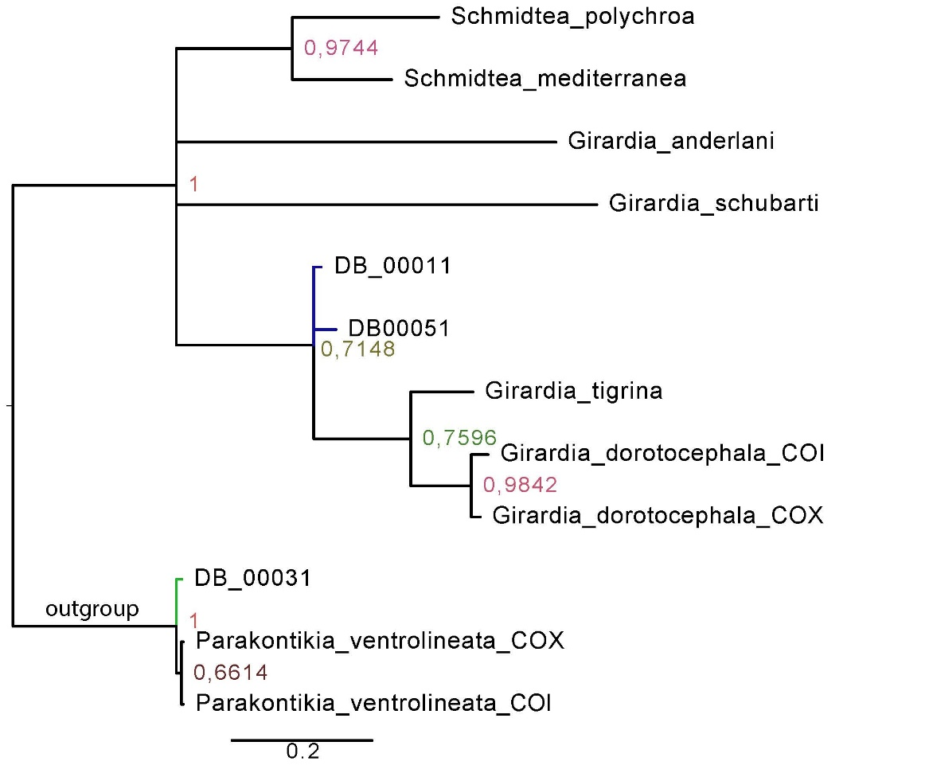
Figure 1. Phylogenetic tree inferred from the concatenated data set by Cytochrome Oxidase I (COI) Bayesian inference analyses. Numbers at nodes are posterior probability values that indicate the level of support of the node under Bayesian inference analyses. Blue branches indicate the freshwater holotypes studied. Green branch indicates the PUCE’s land holotype studied. Scale bar is given in number of substitutions per site.

Figure 2.
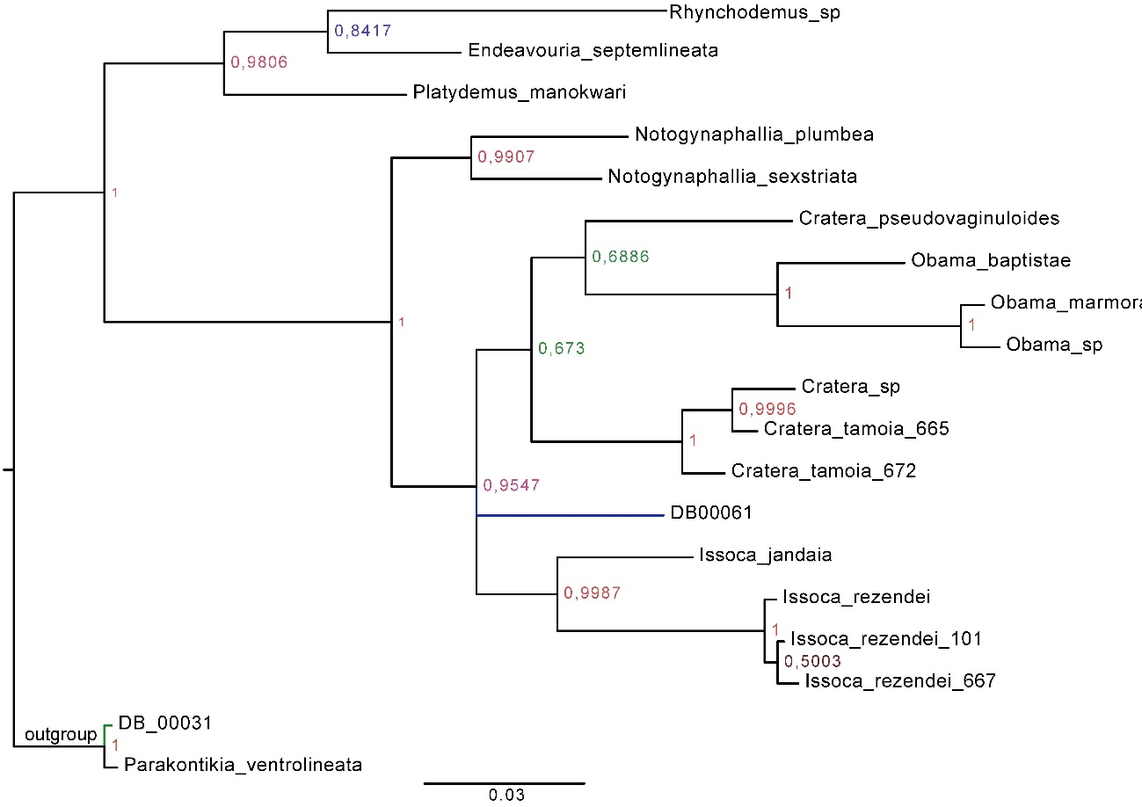
Geoplaninae
Figure 2. Phylogenetic tree inferred from the concatenated data set by Elongation Factor 1-alpha (EF-1a) Bayesian inference analyses. Numbers at nodes are posterior probability values that indicate the level of support of the node under Bayesian inference analyses. Blue branch indicates the Armenia’s land holotype studied. Green branch indicates the PUCE’s land holotype studied. Scale bar is given in number of substitutions per site.

Figure 3.
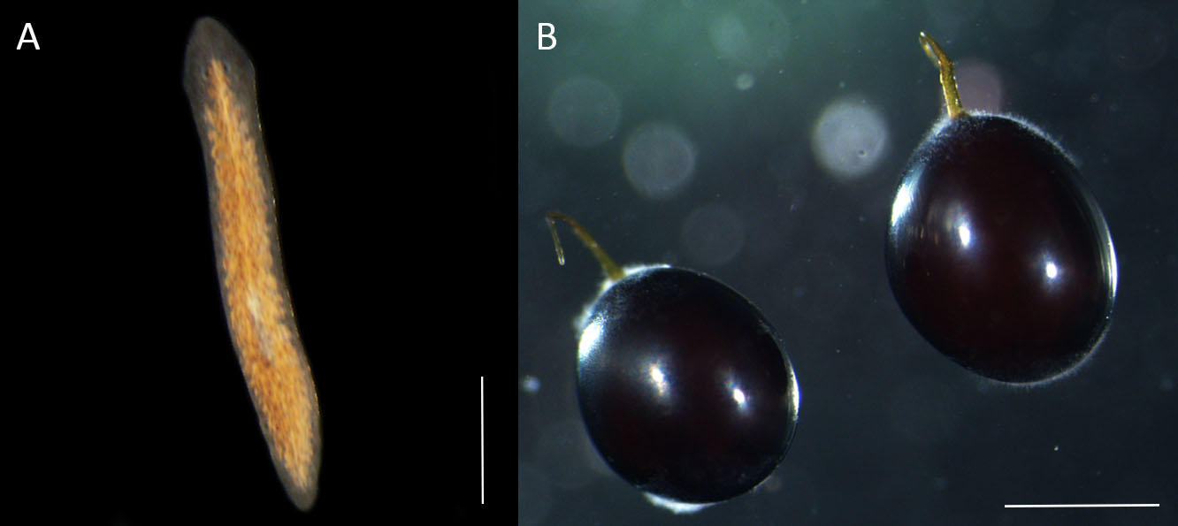
Figure 3. Girardia sp. hatchlings (A) and cocoons (B). (A) The Hatchlings do not present pigmentation. (B) Cocoons are spherical, stalked and stacked to a substrate with an endplate. Scale bar is 0.5 mm.

Figure 4.
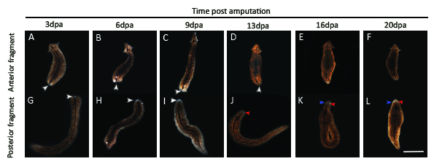
Figure 4. Girardia’s regenerative process post middle transverse amputation. (A-L) Follow up of posterior and anterior regeneration post-amputation in anterior and posterior fragments respectively from 3 to 20 days post amputation (dpa) (n=8). (A, G) Blastema formation (st2); 3 dpa. (B, C, H, I) Growth and early differentiation (st3); 6 and 9dpa. (D, J) Late differentiation (st4); 13dpa. (E, F, K, L) Tissue remodeling. In this and figure 4, white arrowheads indicate the blastema, blue arrowheads indicate completely formed auricles, and red arrowheads indicate the eyespots. Scale bar is 2mm.

Figure 5.
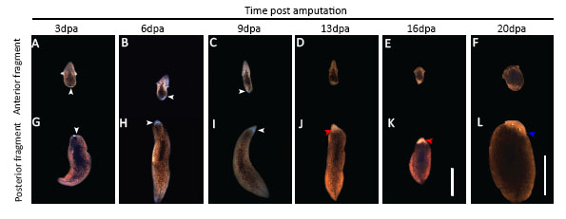
Figure 5. Girardia’s regenerative process post head amputation. (A-L) Follow up of posterior and anterior regeneration post-amputation in anterior and posterior fragments respectively from 3 to 20 dpa (n=8). (A, G) Blastema’s formation (st2); 3dpa. (B, C, H, I) Growth and early differentiation (st3); 6 and 9dpa. (D, J) Late differentiation (st4); 13dpa. (E, F, K, L) Tissue remodeling. White arrowheads indicate the blastema, blue arrowheads indicate completely formed auricles, and red arrowheads indicate the eyespots. Scale bar is 2mm.

Figure 6.
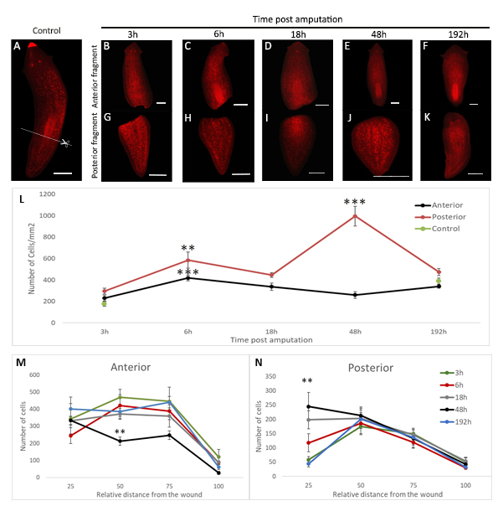
Figure 6. Neoblasts response after amputation in Girardia sp. (A-K) Whole-mount planarian’s amputated fragments labeled with anti-H3P antibody at indicated time points. Representative anterior and posterior fragments are shown. (A) Intact planarian. (B-F) Anterior labeled fragments. (G-K) Posterior labeled fragments. Scale bars 0.5cm. The white dotted line with scissors indicates the transversal cut made. (L) Change in mitotic density in the anterior (black line) and posterior (red line) fragments after amputation. The average of mitotic cells per mm² is shown at 3h, 6h, 18h, 48h, 192h time points. Numbers were significantly higher at 6h versus 3h in anterior and posterior fragments; ***p<0.0005426, **p<0.01, Student’s t-test. Numbers were significantly higher at 48h versus 18h in posterior fragments; ***p<0.0001, Student’s t-test. (M) Mitotic numbers at different relative distances from the wound site in anterior fragments. Numbers were significantly different at 48h versus 3h and 6h; **p< 0.00926, ANOVA test. (N) Mitotic numbers at different relative distances from the wound site in posterior fragments. Numbers were significantly different at 48h versus 3h and 192h; **p< 0.00132, ANOVA test. (L-N) Error bars represent the median standard deviation in relation to the number of samples (n=6). The relative distance from the wound is a category that represent the spatial position of the planarian fragment on which a PH3 positive cell is located. In the first category (25) are grouped all the PH3 positive cells located within a distance between 0% to 25% from the wound site, relative to the total length of the fragment; in the second category (50) are grouped all the PH3 positive cells located within a distance between 26% to 50% from the wound site; in the third category (75) are grouped all the PH3 positive cells located within a distance between 51% to 75% from the wound site, and in the fourth category (100) are grouped all the PH3 positive cells located within a distance between 76% to 100% from the wound site, being the most distant category. Differences between groups were analyzed with the Tukey tests.

Figure 7.
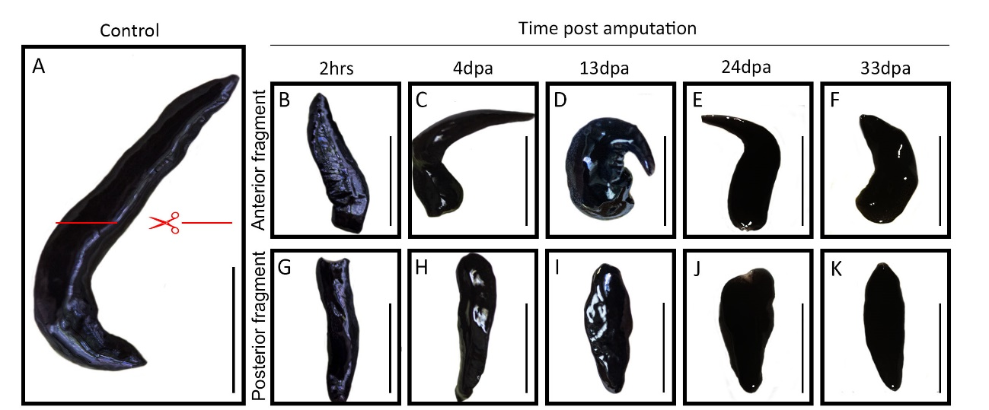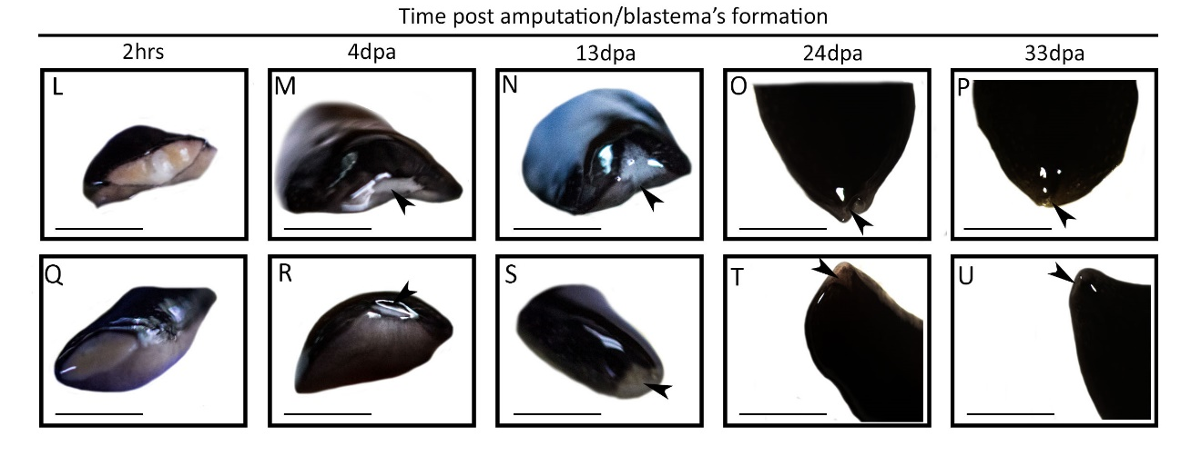 Figure 7. Geoplaninae sp. regenerative process post middle transverse amputation. (A-K) Follow up of posterior and anterior regeneration post amputation in anterior and posterior fragments respectively from 2 hours post-amputation to 33 dpa (n=8). Scale bar, 1cm. (L-U) Amplification images of regenerating tissue. (L, M, Q, R) Wound healing (st1); 2h and 4dpa. (N, S) Blastema’s formation (st2); 13dpa. (O, T) Growth and early differentiation (st3); 24dpa. (P, U) Late differentiation (st4); 33dpa. Black arrowheads show exposed tissue on 2hpa and blastema’s generation on next stages. Scale bar is 0.5cm.

Figure 8.
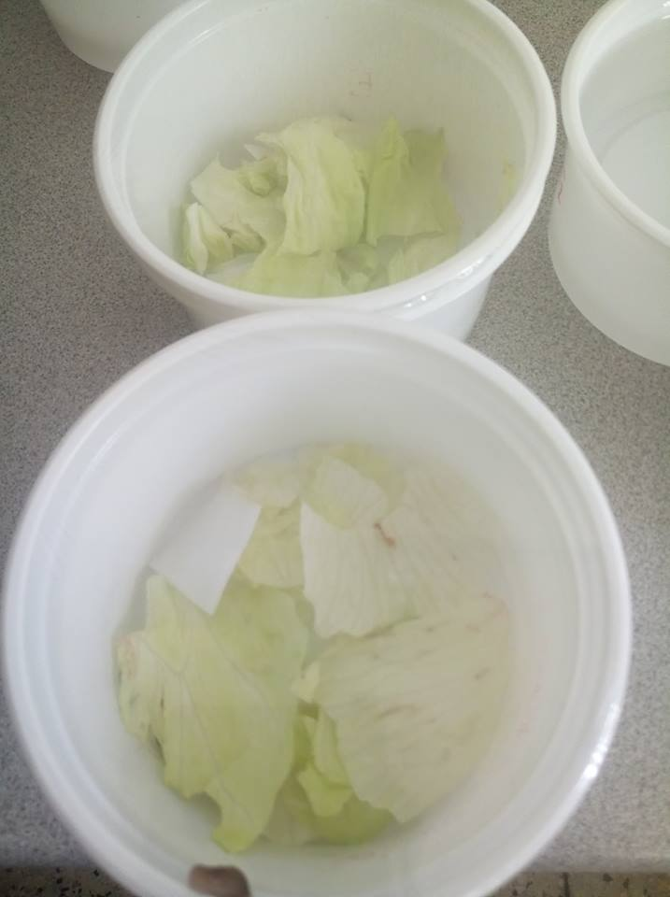
Figure 8. Land planarians terrarium. A photograph of two terraria is shown. Wet paper towels are distributed on the terrarium base and lettuce leaves are distributed above them.

Appendix 1. Primers used in this research
Genomic region | Primer Name | Sequence | Source
COI | FlatwormCOIF | GCAGTTTTTGGTTTTTTGGACATCC | (Sunnucks et al., 2006)
 | FlatwormCOIR | GAGCAACAACATAATAAGTATCATG | (Sunnucks et al., 2006)
EF-1a | EFplatF | GATTGCYCCWGGYCATCG | (Carbayo et al., 2013)
 | EFplatR | GCRATWGAYTCGTGRTGC | (Carbayo et al., 2013)

